

**OBJECTIVES:**

Upon successful completion of this experiment, the student will be able to:

1. Describe the parameters of short transmission line
2. Solve problems involving the parameters of transmission line.
3. Illustrate with correct label and dimension.

**SUMMARY OF THEORY**

Applicable to lines up to 80.45 km (50 miles) long. Equivalent circuit of short transmission line consists of series combination of line resistance and inductive reactance. Line capacitance ignored!

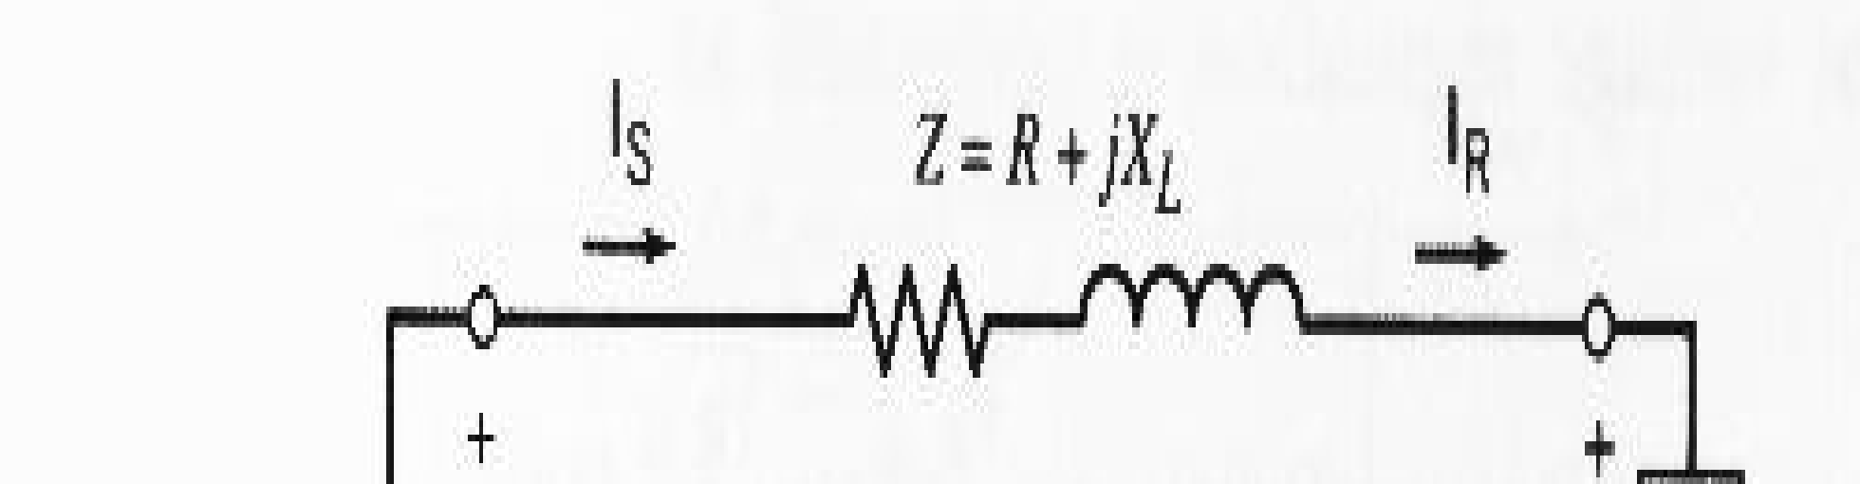

• No shunt branches

Current at sending end is equal to current at receiving end Is = IR

• Voltage at sending end given by: Vs = VR + IRZ

• Voltage regulation

Increase in receiving end voltage as load reduced from full load to no load with sending end voltage

held constant

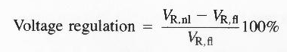

**Problem**:

A transmission line 60 miles long is made up of copper conductors with the following constants R = 0.4 ohms/mile, inductance = 2.0 mH / mile. If the load is 100 MW at 69 kV, 0.85 pf lagging, Calculate : a) Sending End Voltage per phase, b) Sending End Power , If connected

1. Single Phase

2. Three Phase

AFTER YOUR SOLUTION AND COMPUTATIONS, IN THREE PARAGRAPHS WRITE YOUR OBSERVATIONS AND A MAXIMUM OF TWO SENTENCES YOUR CONCLUSION.

Solution/Computations starts here:

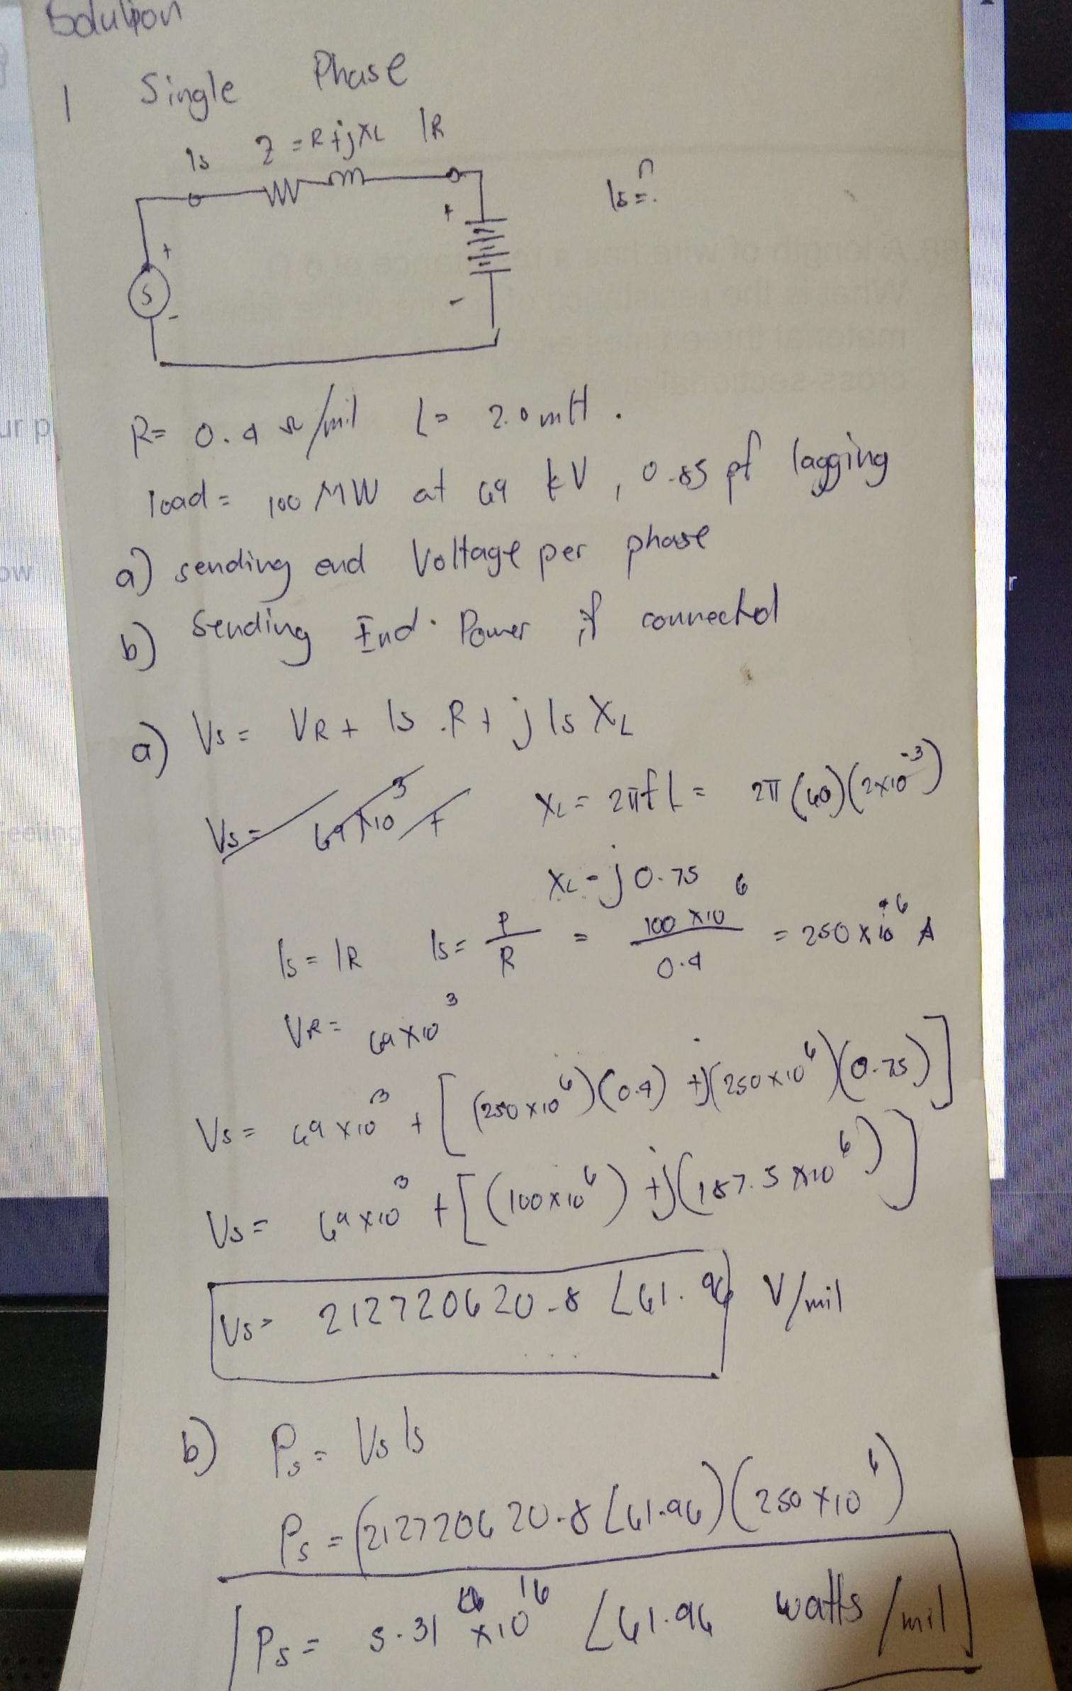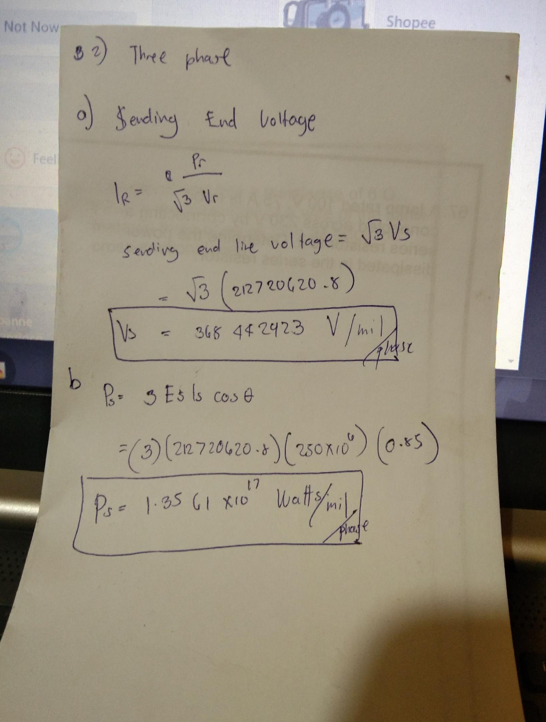

CONCLUSION:

Therefore i conclude that voltage sending end in single phase short line is much lower value in voltage and in power. but some cases the results is interval base on how much resistance is applied but when it has the same value it is guaranteed that the 3 phase has much value output.